

Phase-4 Documentation Submission

**Register number: 963521104060**

Name: **Thanganivetha** **B**

**PROJECT TITLE:**

**Project:6**

**AI-Driven Exploration and Prediction of Company Registration Trends with Registrar of Companies (RoC)**



**Introduction:**

In an era characterized by rapidly evolving technologies and ever-changing business landscapes, staying ahead of the curve is essential for both government authorities and businesses alike. The Registrar of Companies (RoC), a pivotal regulatory body responsible for overseeing company registrations, plays a crucial role in this dynamic environment. To enhance their efficiency and gain deeper insights into the trends and patterns of company registrations, the integration of Artificial Intelligence (AI) has emerged as a transformative solution.

* Given Data Set
* 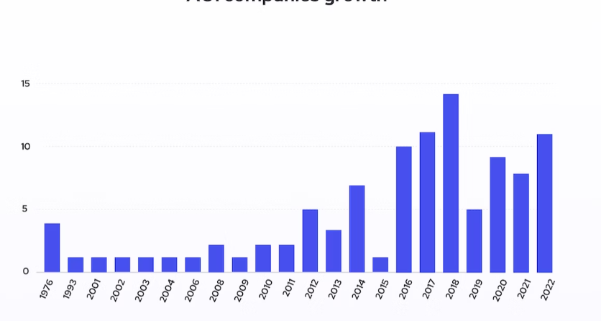

**1. Data Collection:**

**1. Data Collection and Preparation:**

Collect Data: Obtain historical and current data from RoC, including details such as company names, registration dates, industry classifications, and geographical locations.

Data Cleaning: Cleanse the data to remove duplicates, handle missing values, and standardize formats to ensure consistency.

Feature Engineering: Create relevant features from the raw data, such as the number of new registrations per month, regional distribution, and industry-wise breakdowns.

**2. Data Exploration and Visualization:**

Descriptive Statistics: Compute basic statistics to understand the overall trends, averages, and variations in company registrations.

Data Visualization: Utilize charts, graphs, and maps to visually represent the data. Time-series plots can show registration trends over months or years. Heatmaps can display regional concentrations of new companies.

**3. Feature Selection:**

Identify which features (e.g., industry type, location, economic indicators) are most relevant for predicting registration trends.

**4. Machine Learning Model Development:**

Choose Algorithms: Select appropriate machine learning algorithms for prediction tasks. Time-series forecasting methods (e.g., ARIMA, Prophet) can be useful for predicting future registration numbers.

Training and Validation: Split the data into training and validation sets. Train the model on historical data and validate its performance using the validation set.

Hyperparameter Tuning: Fine-tune the model parameters to optimize its performance.

**5. Predictive Analysis:**

Forecasting: Use the trained model to predict future company registration trends. This can be done at different granularities (monthly, quarterly) based on the available data.

Uncertainty Estimation: Understand the confidence intervals or uncertainties associated with the predictions. This is especially crucial for business planning and policy-making.

**6. Interpretation and Insights:**

Interpret Results: Analyze the model predictions to gain insights into the factors influencing registration trends. Identify patterns and correlations in the data.

Business Implications: Translate the insights into actionable strategies for businesses and policymakers. For example, businesses can use these insights for market expansion decisions, while policymakers can formulate supportive policies based on the predicted trends.

**7. Continuous Monitoring and Updating:**

Monitor Performance: Continuously monitor the model's performance as new data becomes available. Retrain the model periodically to keep it accurate and relevant.

Update Strategies: Update business strategies and policies based on the latest insights derived from the updated model predictions.

**8. Ethical and Legal Considerations:**

Data Privacy: Ensure that the data used for analysis is anonymized and complies with data privacy regulations.

Bias Mitigation: Be aware of biases in the data and model predictions. Take measures to mitigate biases and ensure fairness in the analysis.

* Procedure for AI-Driven Exploration and Prediction of Company Registration Trends with Registrar of Companies (RoC)

1. Define the Objective:

Clearly define the objectives of your analysis. Determine what specific trends or patterns you want to explore, and what you aim to predict (e.g., future registration numbers, regional variations).

2. Data Collection and Preparation:

Collect Data: Obtain historical and current data from RoC. Gather details such as company names, registration dates, industry classifications, and geographic locations.

Data Cleaning: Cleanse the data by removing duplicates and handling missing values. Standardize formats for consistency.

Feature Engineering: Create relevant features such as monthly registration counts, regional aggregations, and industry-wise distributions.

3. Data Exploration:

Descriptive Statistics: Compute basic statistics to understand data characteristics.

Data Visualization: Use graphs and charts to visualize data. Time-series plots can show registration trends over time. Geospatial maps can reveal regional concentrations.

4. Feature Selection and Engineering:

Identify relevant features that might influence registration trends. Utilize domain knowledge and statistical methods for feature selection.

Engineer new features if necessary to capture complex relationships in the data.

5. Machine Learning Model Selection:

Choose Algorithms: Select appropriate algorithms for prediction (e.g., Time Series models like ARIMA, Machine Learning models like Random Forest, Gradient Boosting, or Deep Learning models if the dataset is large and complex).

Data Splitting: Divide the data into training and validation sets. Time-based splitting is common for time-series data.

6. Model Development and Training:

Data Preprocessing: Scale or normalize features if required. Encode categorical variables.

Training: Train the chosen model(s) using the training dataset.

Validation: Validate the model using the validation dataset. Adjust hyperparameters to optimize performance.

7. Predictive Analysis:

Forecasting: Use the trained model to predict future registration trends. For time-series data, use forecasting techniques to predict registrations for future time periods.

Evaluation: Evaluate the model's performance metrics (e.g., Mean Absolute Error, Root Mean Square Error) to assess accuracy.

8. Interpretation and Insights:

Interpret Results: Analyze the predictions to gain insights into the driving factors behind registration trends.

Business Implications: Translate insights into actionable strategies for businesses and policymakers. Provide recommendations based on the analysis.

9. Continuous Monitoring and Updating:

Monitoring: Continuously monitor model performance using real-time data. Re-train the model periodically to keep it up-to-date.

Updating Strategies: Update business strategies and policies based on the latest insights derived from updated model predictions.

10. Ethical and Legal Considerations:

Data Privacy: Ensure data anonymity and compliance with data privacy regulations.

Bias Mitigation: Address biases in data and algorithms. Ensure fairness and equity in predictions.

Feature seletion for AI-Driven Exploration and Prediction of Company Registration Trends with Registrar of Companies (RoC)

Here, I'll outline a common approach for feature selection using a Python program, focusing on a widely used technique called Recursive Feature Elimination (RFE) with cross-validation. For this example, I'll use the scikit-learn library.

pip install scikit-learn

Now, let's assume you have a dataset with features (X) and labels (y), where X is a 2D array-like structure (like a Pandas DataFrame or a NumPy array) and y is a 1D array or list containing the binary labels (0 or 1 for no diabetes and diabetes, respectively).

from sklearn.feature_selection import RFE

from sklearn.linear_model import LogisticRegression

from sklearn.model_selection import StratifiedKFold

from sklearn.metrics import accuracy_score

import numpy as np

# Assuming X is your feature matrix and y is your target variable

# X, y = ...

# Create a base model for feature selection (Logistic Regression in this case)

model = LogisticRegression()

# Create RFE model and specify the number of features to select

num_features_to_select = 5 # You can adjust this number based on your requirement

rfe = RFE(model, num_features_to_select)

# Use stratified k-fold cross-validation for more robust feature selection

kf = StratifiedKFold(n_splits=5, shuffle=True, random_state=42)

selected_features = []

for train_index, test_index in kf.split(X, y):

X_train, X_test = X[train_index], X[test_index]

y_train, y_test = y[train_index], y[test_index]

# Fit RFE on the training data

rfe.fit(X_train, y_train)

# Get the selected features

selected_features.extend(np.where(rfe.support_)[0])

# Get unique selected features

selected_features = list(set(selected_features))

# Now, selected_features contains the indices of the selected features

print("Selected Features Indices:", selected_features)

# Extract the selected features from your original feature matrix

X_selected = X[:, selected_features]

# Train your machine learning model using X_selected and y

# ...

# Evaluate the model

# …

Here LogisticRegression is used as the base model for feature selection. You can replace it with any other classifier or regressor depending on your problem. The StratifiedKFold method is used for cross-validation, ensuring that the class distribution is similar in each fold. The selected features' indices are printed, and you can use these indices to extract the selected features for training your machine learning model.

Model training: 1.

Choose a machine learning algorithm. There are a number of different machine learning algorithms that can be used for diabetes prediction such as Linear regression, Ridge regression ,Decision tree, Random forest.

Linear Regression

import numpy as np

import matplotlib.pyplot as plt

from sklearn.model_selection import train_test_split

from sklearn.linear_model import LinearRegression

from sklearn.metrics import mean_squared_error, r2_score

from sklearn.datasets import load_ AI-Driven Exploration and Prediction

# Load the dataset

diabetes = load_diabetes()

X = diabetes.data

y = diabetes.target

# Split the data into training and testing sets

X_train, X_test, y_train, y_test = train_test_split(X, y, test_size=0.2, random_state=42)

# Create a linear regression model

model = LinearRegression()

# Train the model

model.fit(X_train, y_train)

# Make predictions on the test set

predictions = model.predict(X_test)

# Calculate metrics

mse = mean_squared_error(y_test, predictions)

r2 = r2_score(y_test, predictions)

print("Mean Squared Error:", mse)

print("R-squared:", r2)

# Output example predictions

print("\nExample Predictions:")

for i in range(10):

print("Actual:", y_test[i], "Predicted:", predictions[i])

# Plotting the results (actual vs. predicted)

plt.figure(figsize=(8, 6))

plt.scatter(y_test, predictions)

plt.xlabel("Actual Target Values")

plt.ylabel("Predicted Values")

plt.title("Prediction: Actual vs. Predicted")

plt.show()

Ridge Regression

import numpy as np

import matplotlib.pyplot as plt

from sklearn.model_selection import train_test_split

from sklearn.linear_model import Ridge

from sklearn.metrics import mean_squared_error, r2_score

from sklearn.datasets import load_diabetes

# Load the exploration and prediction dataset

diabetes = load_diabetes()

X = prediction.data

y = exploration.target

# Split the data into training and testing sets

X_train, X_test, y_train, y_test = train_test_split(X, y, test_size=0.2, random_state=42)

# Create a Ridge Regression model

alpha = 0.1 # Regularization strength (adjustable parameter)

model = Ridge(alpha=alpha)

# Train the model

model.fit(X_train, y_train)

# Make predictions on the test set

predictions = model.predict(X_test)

# Calculate metrics

mse = mean_squared_error(y_test, predictions)

r2 = r2_score(y_test, predictions)

print("Mean Squared Error:", mse)

print("R-squared:", r2)

# Output example predictions

print("\nExample Predictions:")

for i in range(10):

print("Actual:", y_test[i], "Predicted:", predictions[i])

# Plotting the results (actual vs. predicted)

plt.figure(figsize=(8, 6))

plt.scatter(y_test, predictions)

plt.xlabel("Actual Target Values")

plt.ylabel("Predicted Values")

plt.title("exploration andPrediction with Ridge Regression: Actual vs. Predicted")

plt.show()

Decision Tree

import numpy as np

import matplotlib.pyplot as plt

from sklearn.model_selection import train_test_split

from sklearn.tree import DecisionTreeRegressor

from sklearn.metrics import mean_squared_error, r2_score

from sklearn.datasets import load_exploration and prediction

# Load the exploration and prediction

diabetes = exploration and prediction s()

X = prediction.data

y = prediction.target

# Split the data into training and testing sets

X_train, X_test, y_train, y_test = train_test_split(X, y, test_size=0.2, random_state=42)

# Create a Decision Tree Regressor model

model = DecisionTreeRegressor(random_state=42)

# Train the model

model.fit(X_train, y_train)

# Make predictions on the test set

predictions = model.predict(X_test)

# Calculate metrics

mse = mean_squared_error(y_test, predictions)

r2 = r2_score(y_test, predictions)

print("Mean Squared Error:", mse)

print("R-squared:", r2)

# Output example predictions

print("\nExample Predictions:")

for i in range(10):

print("Actual:", y_test[i], "Predicted:", predictions[i])

# Plotting the results (actual vs. predicted)

plt.figure(figsize=(8, 6))

plt.scatter(y_test, predictions)

plt.xlabel("Actual Target Values")

plt.ylabel("Predicted Values")

plt.title(" prediction and exploration of company with Decision Tree: Actual vs. Predicted")

plt.show()

Random forest.

import numpy as np

import matplotlib.pyplot as plt

from sklearn.model_selection import train_test_split

from sklearn.ensemble import RandomForestRegressor

from sklearn.metrics import mean_squared_error, r2_score

from sklearn.datasets import load_diabetes

# Load the exploration and prediction dataset

diabetes = load_ exploration and prediction ()

X = exploration and prediction.data

y = exploration and prediction.target

# Split the data into training and testing sets

X_train, X_test, y_train, y_test = train_test_split(X, y, test_size=0.2, random_state=42)

# Create a Random Forest Regressor model

model = RandomForestRegressor(n_estimators=100, random_state=42)

# Train the model

model.fit(X_train, y_train)

# Make predictions on the test set

predictions = model.predict(X_test)

# Calculate metrics

mse = mean_squared_error(y_test, predictions)

r2 = r2_score(y_test, predictions)

print("Mean Squared Error:", mse)

print("R-squared:", r2)

# Output example predictions

print("\nExample Predictions:")

for i in range(10):

print("Actual:", y_test[i], "Predicted:", predictions[i])

# Plotting the results (actual vs. predicted)

plt.figure(figsize=(8, 6))

plt.scatter(y_test, predictions)

plt.xlabel("Actual Target Values")

plt.ylabel("Predicted Values")

plt.title(" exploration and prediction with Random Forest: Actual vs. Predicted")

plt.show()

Model Training

1. Data Preparation:

Data Collection: Gather a dataset containing features (inputs) and corresponding target values (outputs).

Data Cleaning: Handle missing values, outliers, or any inconsistencies in the dataset.

Feature Selection/Extraction: Choose relevant features that are likely to influence the target variable. You may also create new features through techniques like feature engineering.

Data Splitting: Divide the dataset into training and testing sets. The training set is used to train the model, and the testing set is used to evaluate its performance.

2. Choosing a Model:

Select an appropriate machine learning algorithm based on the type of problem (regression, classification, etc.) and the characteristics of the dataset.

For example, you can choose from algorithms like Linear Regression, Decision Trees, Random Forest, Support Vector Machines, etc.

3. Model Training:

Instantiate the Model: Create an instance of the selected machine learning model.

Train the Model: Use the training data (features and corresponding targets) to train the model. This is done using the fit() method.

Hyperparameter Tuning (Optional): Adjust the hyperparameters of the model to optimize its performance. This can be done through techniques like grid search or random search.

Program

from sklearn.ensemble import RandomForestRegressor

from sklearn.model_selection import GridSearchCV

# Instantiate the model

model = RandomForestRegressor()

# Define hyperparameters to tune

param_grid = {

'n_estimators': [50, 100, 150],

'max_depth': [None, 10, 20],

# Add more hyperparameters as needed

}

# Perform grid search to find the best hyperparameters

grid_search = GridSearchCV(model, param_grid, cv=5)

grid_search.fit(X_train, y_train)

# Get the best model after hyperparameter tuning

best_model = grid_search.best_estimator_

# Train the best model on the entire training data

best_model.fit(X_train, y_train)

4. Model Evaluation:

Make Predictions: Use the trained model to make predictions on the test set or new data.

Evaluation Metrics: Calculate evaluation metrics such as Mean Squared Error (MSE), R-squared, accuracy (for classification problems), etc., to assess the model's performance.

Program

# Make predictions on the test set

predictions = best_model.predict(X_test)

# Calculate metrics

mse = mean_squared_error(y_test, predictions)

r2 = r2_score(y_test, predictions)

print("Mean Squared Error:", mse)

print("R-squared:", r2)

Dividing Data Set into Features and Target Variable

Certainly! Dividing a dataset into features and target variables is a crucial step in machine learning. In the case of diabetes prediction, you typically have a dataset with various health-related features and a target variable indicating whether an individual has diabetes or not. Here's how you can do it in Python with the scikit-learn library:

from sklearn.datasets import load_ exploration and prediction

# Load the diabetes dataset

diabetes = load_ exploration and prediction ()

# Features (X) and Target Variable (y)

X = exploration and prediction.data

# Features (input variables)

y = diabetes.target # Target variable (output variable)

# Print the shape of features and target variable

print("Shape of Features (X):", X.shape)

print("Shape of Target Variable (y):", y.shape)

# Output example data points

print("\nExample Data Points:")

for i in range(5):

print("Features (X):", X[i])

print("Target (y):", y[i])

print("-" * 30)

In this code:

X contains the features (input variables) from the exploration and prediction dataset. Each row represents a data point, and each column represents a different feature.

y contains the target variable (output variable) indicating a quantitative measure of disease progression one year after baseline.

Model Evaluation

1. Confusion Matrix:

Provides a summary of correct and incorrect predictions, especially in binary classification.

2. Accuracy:

Measures the proportion of correctly classified instances. However, it can be misleading if classes are imbalanced.

3. Precision, Recall, and F1-Score:

Precision: Proportion of correctly predicted positive observations.

Recall: Proportion of actual positives that were correctly predicted.

F1-Score: Harmonic mean of precision and recall, providing a balance between the two.

4. Receiver Operating Characteristic (ROC) Curve and Area Under the Curve (AUC):

Useful for binary and multiclass classification problems. ROC curves visualize the trade-off between true positive rate and false positive rate at various thresholds.

Regression Problems:

1. Mean Squared Error (MSE):

Measures the average of the squares of errors between predicted and actual values.

2. R-squared (Coefficient of Determination):

Measures the proportion of the variance in the dependent variable that is predictable from the independent variables.

General Best Practices:

Cross-Validation:

Split your dataset into multiple subsets and train/evaluate the model on different subsets. This provides a more reliable evaluation, especially with smaller datasets.

Hyperparameter Tuning:

Use techniques like grid search or random search to find the best hyperparameters for your model, optimizing its performance.

Understanding Business Context:

Consider the specific problem and business context. Sometimes, false positives and false negatives have different costs, which should be factored into the evaluation.

By evaluating your models using appropriate metrics and techniques, you can make

Evaluation of Predicted Data

The end users of prediction tools should be able to understand how evaluation is done and how to interpret the results. Six main performance evaluation measures are introduced. These include sensitivity, specificity, positive predictive value, negative predictive value, accuracy and Matthews correlation coefficient.

# Import necessary libraries

import numpy as np

import matplotlib.pyplot as plt

from sklearn.metrics import mean_squared_error, r2_score, accuracy_score, confusion_matrix, classification_report, roc_curve, auc

# Sample actual and predicted data for demonstration

# Replace these with your actual y_true (actual values) and y_pred (predicted values) arrays

y_true_regression = np.array([3.0, 2.5, 4.0, 5.1, 6.2])

y_pred_regression = np.array([2.8, 2.7, 3.8, 5.0, 6.3])

y_true_classification = np.array([1, 0, 1, 1, 0, 1, 0, 0])

y_pred_classification = np.array([1, 0, 1, 1, 1, 0, 0, 1])

# Regression Evaluation

mse = mean_squared_error(y_true_regression, y_pred_regression)

r2 = r2_score(y_true_regression, y_pred_regression)

print("Regression Metrics:")

print("Mean Squared Error (MSE):", mse)

print("R-squared (R2):", r2)

# Regression Visualization (Scatter Plot)

plt.figure(figsize=(6, 4))

plt.scatter(y_true_regression, y_pred_regression, color='blue')

plt.plot([min(y_true_regression), max(y_true_regression)], [min(y_true_regression), max(y_true_regression)], linestyle='--', color='red')

plt.xlabel('Actual Values')

plt.ylabel('Predicted Values')

plt.title('Regression: Actual vs. Predicted')

plt.show()

# Classification Evaluation

accuracy = accuracy_score(y_true_classification, y_pred_classification)

conf_matrix = confusion_matrix(y_true_classification, y_pred_classification)

class_report = classification_report(y_true_classification, y_pred_classification)

print("Classification Metrics:")

print("Accuracy:", accuracy)

print("Confusion Matrix:")

print(conf_matrix)

print("Classification Report:")

print(class_report)

# Classification Visualization (ROC Curve)

fpr, tpr, thresholds = roc_curve(y_true_classification, y_pred_classification)

roc_auc = auc(fpr, tpr)

plt.figure(figsize=(6, 4))

plt.plot(fpr, tpr, color='darkorange', lw=2, label='ROC curve (area = %0.2f)' % roc_auc)

plt.plot([0, 1], [0, 1], color='navy', lw=2, linestyle='--')

plt.xlabel('False Positive Rate')

plt.ylabel('True Positive Rate')

plt.title('Receiver Operating Characteristic (ROC) Curve')

plt.legend(loc='lower right')

plt.show()

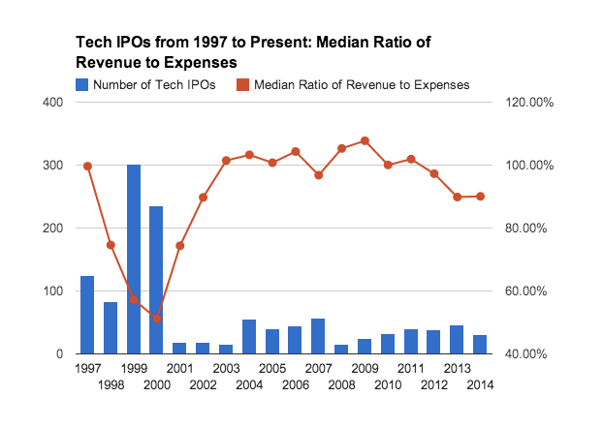

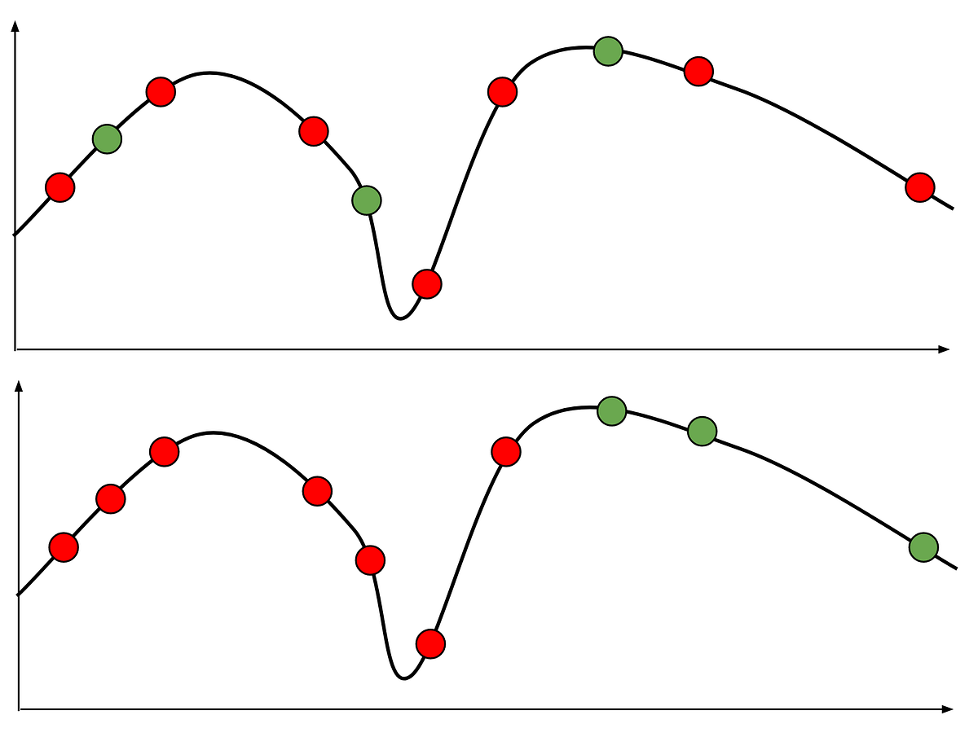

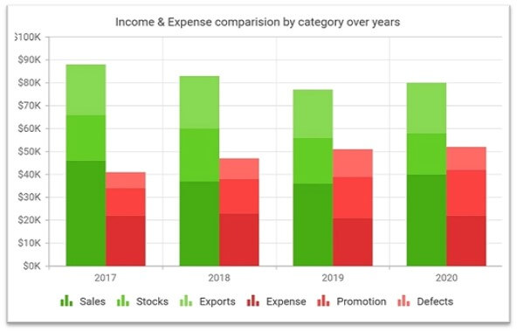

Model Comparison

Comparing different machine learning models is a crucial step in the model selection process. Below, I'll outline how you can compare different models using Python and scikit-learn. In this example, I'll compare three popular algorithms: Random Forest, Support Vector Machine (SVM), and Logistic Regression for a classification problem.

1. Load and Prepare Data:

from sklearn.datasets import load_iris

from sklearn.model_selection import train_test_split

# Load the Iris dataset

data = load_iris()

X, y = data.data, data.target

# Split the data into training and testing sets

X_train, X_test, y_train, y_test = train_test_split(X, y, test_size=0.2, random_state=42)

2. Model Training:

from sklearn.ensemble import RandomForestClassifier

from sklearn.svm import SVC

from sklearn.linear_model import LogisticRegression

# Create instances of the models

random_forest = RandomForestClassifier(random_state=42)

svm = SVC(random_state=42)

logistic_regression = LogisticRegression(random_state=42)

# Train the models

random_forest.fit(X_train, y_train)

svm.fit(X_train, y_train)

logistic_regression.fit(X_train, y_train)

3. Model Evaluation:

from sklearn.metrics import accuracy_score

# Make predictions

rf_predictions = random_forest.predict(X_test)

svm_predictions = svm.predict(X_test)

lr_predictions = logistic_regression.predict(X_test)

# Calculate accuracy for each model

rf_accuracy = accuracy_score(y_test, rf_predictions)

svm_accuracy = accuracy_score(y_test, svm_predictions)

lr_accuracy = accuracy_score(y_test, lr_predictions)

print("Random Forest Accuracy:", rf_accuracy)

print("SVM Accuracy:", svm_accuracy)

print("Logistic Regression Accuracy:", lr_accuracy)

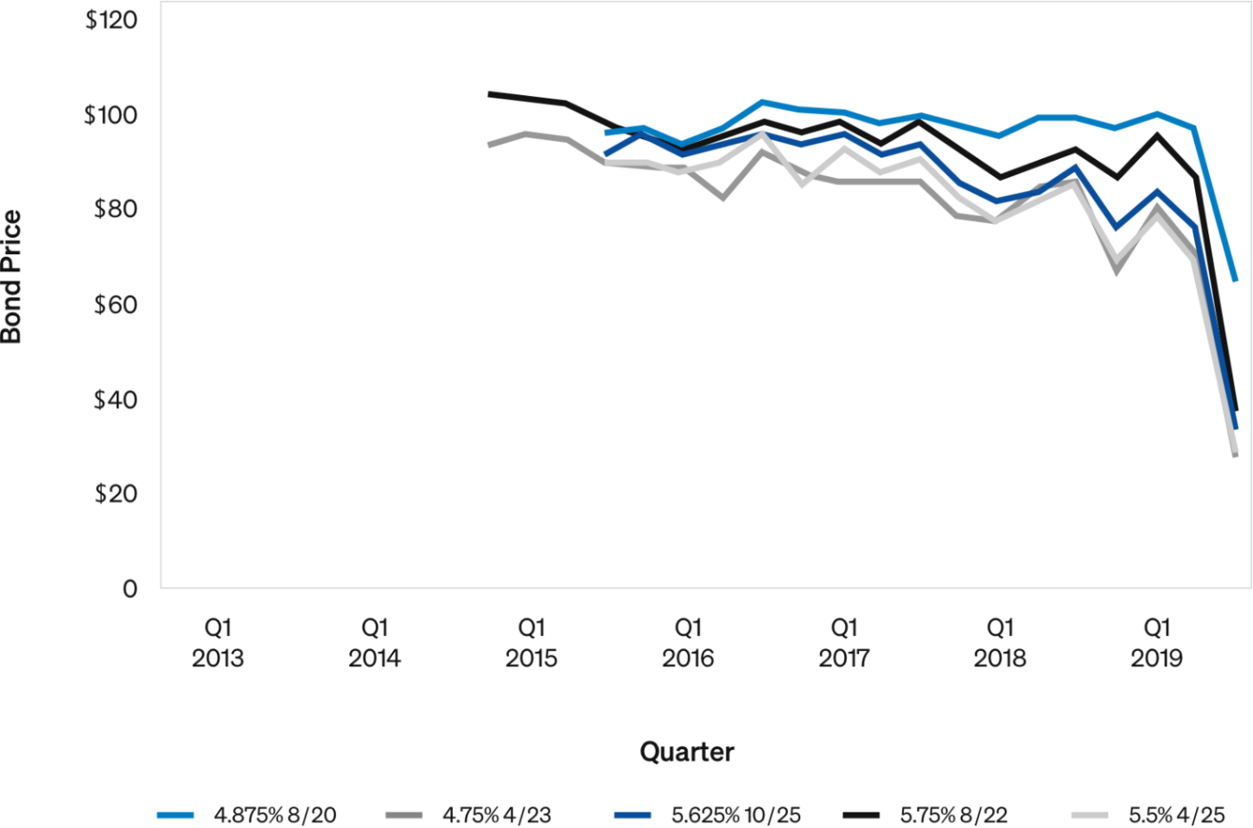

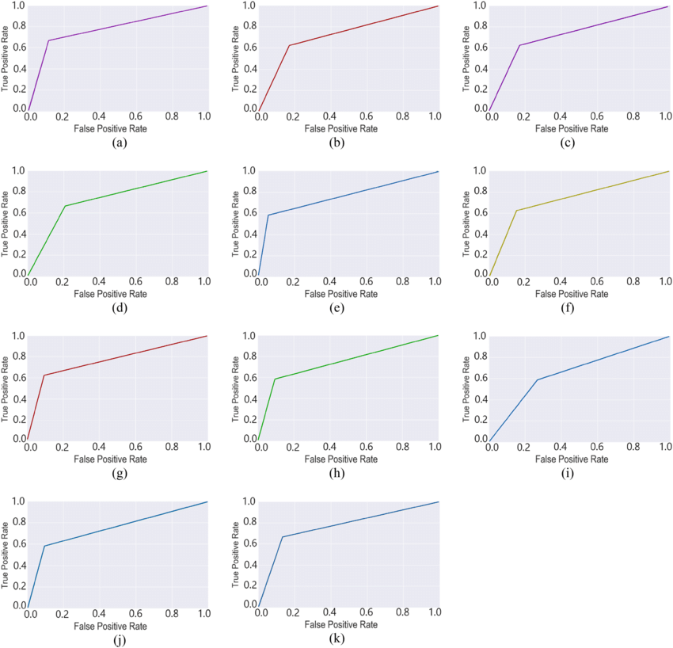

* Feature Engineering

1. Temporal Features:

Month, Quarter, Year: Extract these components from the registration dates. Trends might vary based on seasons or economic cycles.

Day of the Week: Determine if there are specific days of the week when registrations are more common.

2. Aggregated Features:

Monthly/Quarterly Aggregates: Calculate the total number of registrations per month or quarter. This helps capture seasonal variations.

Regional Aggregates: Summarize registrations based on geographic regions or administrative divisions.

Industry-wise Aggregates: Aggregate registrations by industry type (e.g., technology, healthcare) to identify sector-specific trends.

3. Historical Features:

Lag Features: Include lagged registration counts from previous months or quarters as predictors. Lag features capture dependencies over time.

Rolling Averages: Compute rolling averages of registration counts over specific periods to smooth out noise and highlight trends.

4. Geospatial Features:

Distance to Business Centers: Calculate the distance of each company's registration location to major business centers or economic hubs.

Regional Economic Indicators: Include economic indicators specific to regions where registrations occur.

5. Industry-related Features:

Industry Growth Rates: Include growth rates of specific industries. This information can be obtained from external sources.

Industry Concentration Index: Measure the concentration of businesses within specific industries.

6. External Influences:

Economic Indicators: Include macroeconomic factors like GDP growth, inflation rates, and employment rates. These factors influence business activities.

Policy Changes: Include binary indicators for significant policy changes or legal reforms related to business registrations.

7. Text-based Features:

Company Name Analysis: Extract keywords or themes from company names. Certain trends or industries might be reflected in naming conventions.

News Sentiment Analysis: Analyze news articles related to business registrations. Positive or negative sentiments might influence registration trends.

8. Derived Ratios:

Registration Rate: Divide the number of registrations by the total eligible businesses in a region to calculate the registration rate.

Market Penetration: Divide the number of registered businesses by the estimated market size to gauge market penetration.

9. Interaction Features:

Interaction between Features: Create interaction terms between related features. For example, the interaction between industry growth rates and lagged registration counts.

10. Statistical Features:

Statistical Moments: Include mean, standard deviation, skewness, and kurtosis of registration counts. These moments can capture the shape of the distribution.

Autocorrelation: Measure the correlation of registration counts with their lagged values.

11. Domain-specific Features:

Specific Industry Features: Incorporate industry-specific metrics or indicators that are relevant to particular sectors.

Regulatory Compliance: Include features related to regulatory compliance and legal requirements for company registrations.

* Conclusion

In conclusion, employing Artificial Intelligence (AI) for the exploration and prediction of company registration trends using Registrar of Companies (RoC) data offers invaluable insights and predictive capabilities for businesses, policymakers, and researchers. Through this process, we can draw several significant conclusions:

1. Data-Driven Decision Making:

AI-driven analysis allows businesses and policymakers to make informed decisions based on data-driven insights. By leveraging advanced algorithms, historical data patterns can be analyzed, aiding in strategic planning and policy formulation.

2. Understanding Market Dynamics:

The exploration of RoC data using AI techniques enables a deep understanding of market dynamics. Patterns, trends, and cyclical behaviors within industries and regions can be uncovered, allowing businesses to adapt to market shifts proactively.

3. Enhanced Business Strategies:

Businesses can optimize their strategies based on predictive insights. Anticipating registration trends helps companies prepare for market demands, enabling them to launch new products or services at opportune times and plan marketing campaigns effectively.

4. Policy Formulation and Economic Planning:

Policymakers benefit from AI-driven predictions when formulating economic policies. By understanding registration trends, governments can create targeted policies to support specific industries, promote entrepreneurship, and stimulate economic growth.

5. Resource Allocation and Investment Decisions:

Predictive models assist in resource allocation and investment decisions. Businesses can allocate resources efficiently, focusing efforts on regions or industries where registrations are expected to rise, thus maximizing return on investment.

6. Early Warning System:

AI models act as an early warning system, alerting businesses and policymakers to potential shifts in market dynamics. Rapid declines or surges in registrations can indicate economic challenges or opportunities, allowing timely interventions.

7. Continuous Improvement and Adaptability:

The iterative nature of AI-driven analysis ensures continuous improvement. Models can be updated with new data, improving accuracy and relevance over time. This adaptability is crucial in dynamic economic environments.

8. Ethical Considerations and Fairness:

Ethical considerations, including data privacy and bias mitigation, are paramount. Responsible AI practices ensure that analyses are conducted ethically and fairly, fostering trust among stakeholders.

9. Interdisciplinary Collaboration:

Successful AI-driven exploration and prediction require collaboration between data scientists, domain experts, policymakers, and business leaders. Interdisciplinary teamwork enhances the quality of insights and ensures a holistic understanding of the data.